|  |  |
| --- | --- |
| Date | 28 June 2025 |
| Team ID | LTVIP2025TMID49154 |
| Project Name | Comprehensive Analysis and Dietary Strategies with Tableau: A College Food Choices Case Study |
| Maximum Marks | 4 Marks |

**5. Data Flow Diagram (DFD)**

**5.1 Overview**

The Data Flow Diagram (DFD) illustrates the movement of data through the different components of the *College Food Choices Visualization Project*. It captures how raw data is collected, processed, visualized, and presented to end users through an interactive web interface.

This diagram highlights the major components involved, including data sources, preprocessing tools, visualization engine (Tableau), and the web embedding system (Flask).

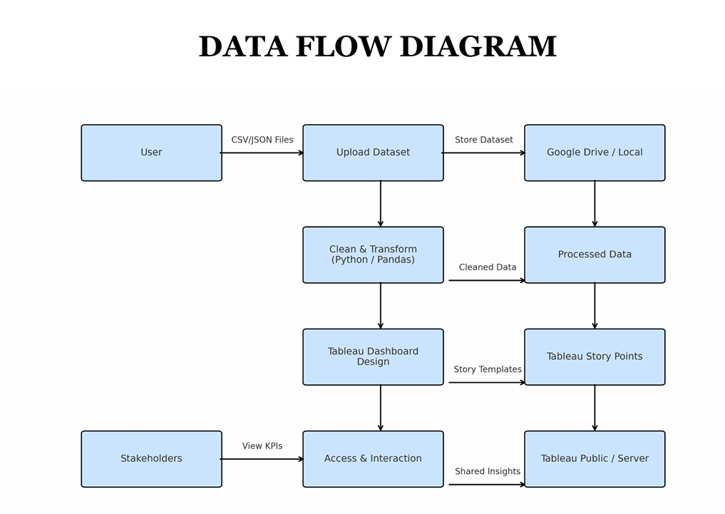

**5.2 DFD – Level 1 Description**

| **Component** | **Description** |
| --- | --- |
| **1. Data Source (CSV)** | Dietary and lifestyle data collected in structured CSV format |
| **2. Data Cleaning & Prep** | Preprocessing in Tableau Prep or directly in Tableau Desktop for filtering, joining, and formatting |
| **3. Tableau Dashboard** | Interactive visualizations built using Tableau Desktop |
| **4. Tableau Server / Public** | Dashboard hosted on Tableau Public or Tableau Server for embedding |
| **5. Flask Web App** | Lightweight Python-based web application to embed and serve Tableau dashboards |
| **6. End Users** | Students, nutritionists, university staff — access insights via browser |

**5.3 Data Flow Description**

|  |
| --- |
| A[CSV Dataset<br>Raw Student Data] --> B[Data Cleaning<br>Tableau Prep / Desktop]  B --> C[Tableau Dashboard<br>Visualizations Built]  C --> D[Tableau Public / Server<br>Hosted Dashboards]  D --> E[Flask Web App<br>Dashboard Embedded in HTML]  E --> F[End User<br>Views Dashboard in Browser] |

**5.4 Key Considerations**

* **Security:** The data does not include sensitive personal details, ensuring privacy while still delivering insight.
* **Scalability:** The system can support additional data sources or student cohorts in future phases.
* **Flexibility:** Tableau Public allows fast updates; changes to the dataset reflect in real-time visuals.